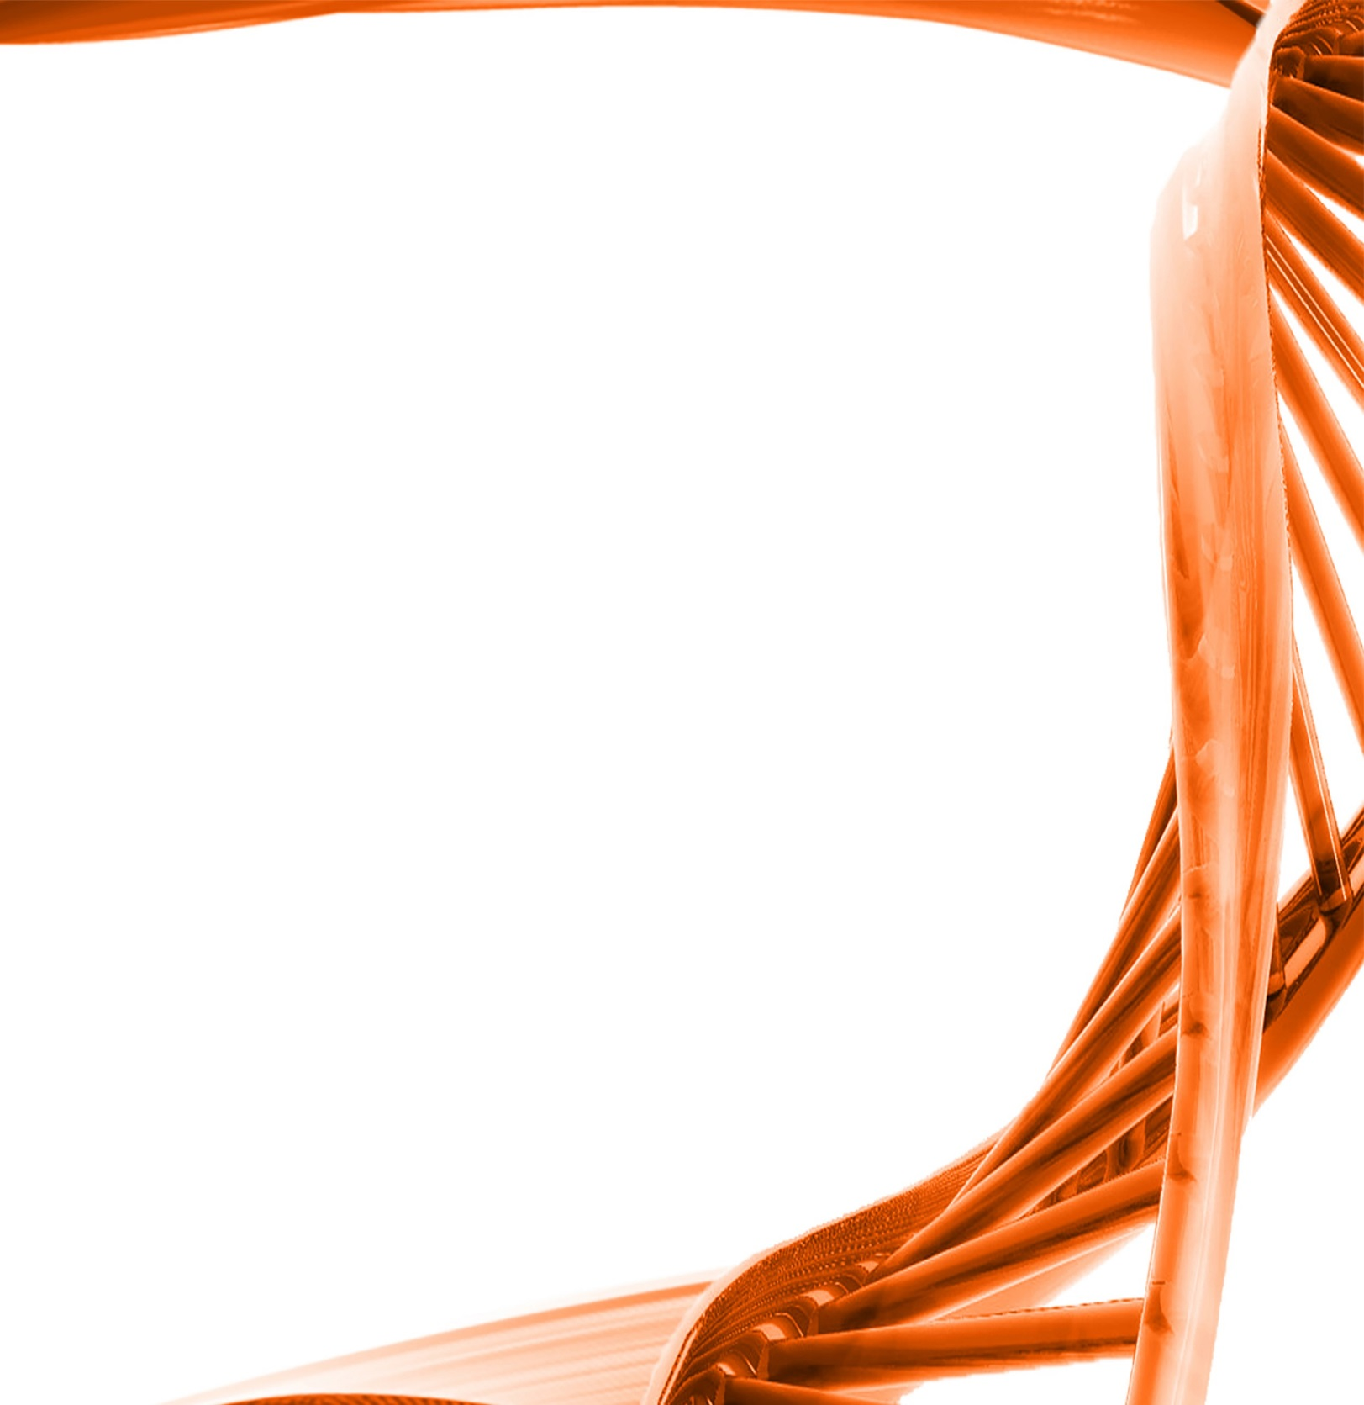

MICROBIOLOGY & MOLECULAR GENETICS
Departmental Journal Club
MICR 6120

Monday
February 27th, 2017
11:30am-12:20pm
RM 215 LSE.

Presented by
Khadija Abdulhafid
PHD Student

Title: The Hha-TomB Toxin-Antitoxin System Shows Conditional Toxicity and Promotes Persister Cell Formation by Inhibiting Apoptosis-Like Death in S. Typhimurium
Authors: Sangeeta Jaiswal, Prajita Paul, Chandrashekhar Padhi, Shilpa Ray, Daniel Ryan, Shantoshini Dash & Mrutyunjay Suar

