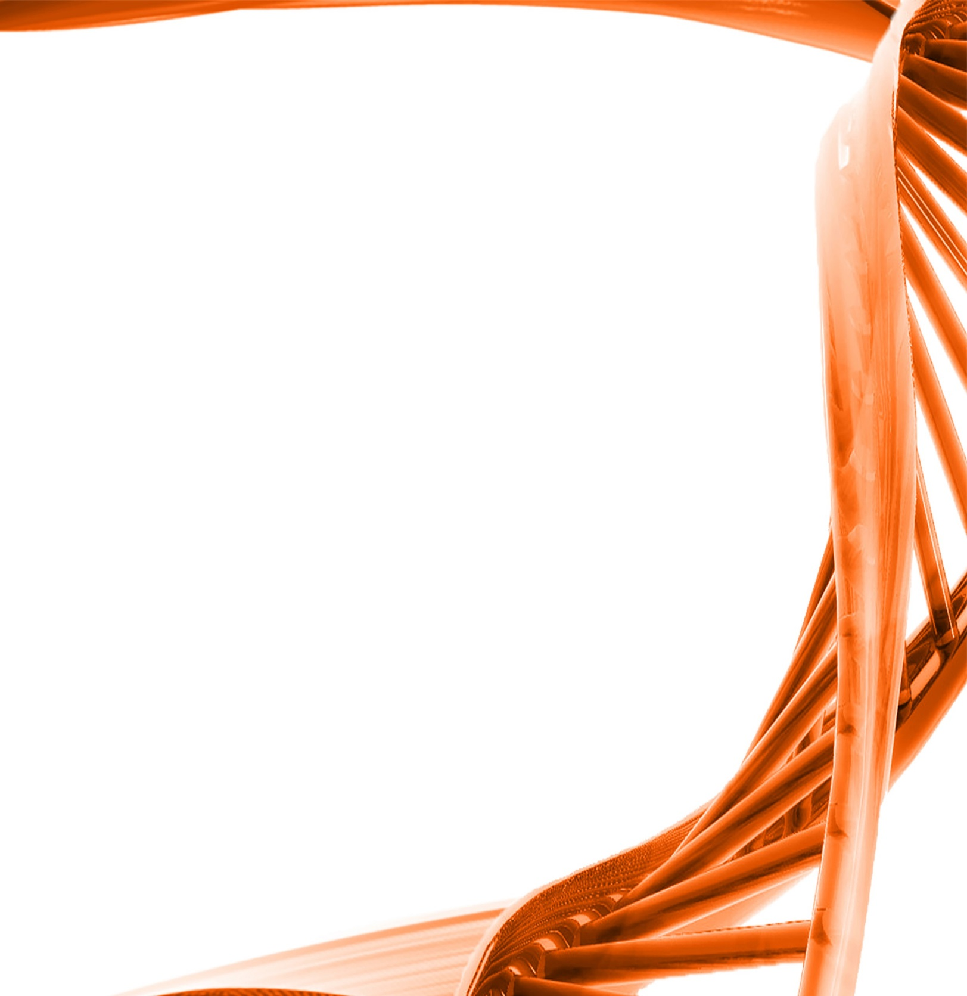

MICROBIOLOGY & MOLECULAR GENETICS
Departmental Journal Club
MICR 6120

Monday
November 7th, 2016
11:30am-12:20pm
RM 122 Classroom Bldg.

Presented by
Biraj Kayastha
PHD Student

Title: Neuraminidase A-Exposed Galactose Promotes Streptococcus pneumoniae Biofilm Formation during Colonization

Authors: Krystle A. Blanchette, Anukul T. Shenoy, Jeffrey Milner II, Ryan P. Gilley, Erin McClure, Cecilia A. Hinojosa, Nikhil Kumar, Sean C. Daugherty, Luke J. Tallon, Sandra Ott, Samantha J. King, Daniela M. Ferreira, Stephen B. Gordon, Hervé Tettelin, Carlos J. Orihuela
Streptococcus pneumoniae is an opportunistic pathogen that colonizes the nasopharynx. Herein we show that carbon availability is distinct between the nasopharynx and bloodstream of adult humans: glucose is absent from the nasopharynx, whereas galactose is abundant. We demonstrate that pneumococcal neuraminidase A (NanA), which cleaves terminal sialic acid residues from host glycoproteins, exposed galactose on the surface of septal epithelial cells, thereby increasing its availability during colonization. We observed that S. pneumoniae mutants deficient in NanA and -galactosidase A (BgaA) failed to form biofilms in vivo despite normal biofilm-forming abilities in vitro. Subsequently, we observed that glucose, sucrose, and fructose were inhibitory for biofilm formation, whereas galactose, lactose, and low concentrations of sialic acid were permissive. Together these findings suggested that the genes involved in biofilm formation were under some form of carbon catabolite repression (CCR), a regulatory network in which genes involved in the uptake and metabolism of less-preferred sugars are silenced during growth with preferred sugars. Supporting this notion, we observed that a mutant deficient in pyruvate oxidase, which converts pyruvate to acetyl-phosphate under non-CCR-inducing growth conditions, was unable to form biofilms. Subsequent comparative transcriptome sequencing (RNA-seq) analyses of planktonic and biofilm-grown pneumococci showed that metabolic pathways involving the conversion of pyruvate to acetyl-phosphate and subsequently leading to fatty acid biosynthesis were consistently upregulated during diverse biofilm growth conditions. We conclude that carbon availability in the nasopharynx impacts pneumococcal biofilm formation in vivo. Additionally, biofilm formation involves metabolic pathways not previously appreciated to play an important role.

